Expt 4 Configure SMTP and FTP protocols using Packet Tracer

Objectives
(i) To configure and test email communication between networked devices using the SMTP protocol and verify successful message delivery through a mail server.
Software/Apparatus required:
(i) Cisco Packet Tracer
(ii) End Devices (PCs)
(iii) Switches
(iv) Copper Straight-through Cable / Automatic Cable Selector
(v) Routers
(vi) Server (Email server or FTP Server)
Procedure
Objective 1: SMTP Protocol
1. Create the network topology using two PCs, switches, a router, and a server in Cisco Packet Tracer.
2. Configure the necessary network settings on all devices and ensure that the router interfaces are enabled.
3. Verify connectivity between the PCs and the server using the ping command.
4. Open the server configuration window and enable the SMTP and POP3 services.
5. Create email accounts for the users on the server by specifying usernames and passwords.
6. Open the Email application on each PC and configure the email account details, including the email address, username, password, and mail server information.
7. From the sender PC, compose a new email by entering the recipient’s email address, subject, and message content.
8. Click Send to transfer the email to the mail server using the SMTP protocol.
9. On the recipient PC, open the Email application and click Receive to retrieve the email from the server using the POP3 protocol.
10. Verify that the email is successfully received in the recipient’s inbox.
11. Repeat the process with different users, if required, to confirm successful email communication.
Network Diagram
Objective 1: SMTP Protocol
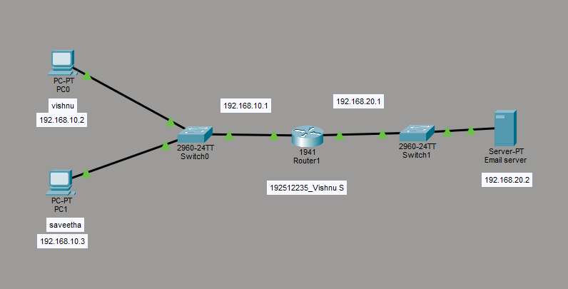

Objective 1: SMTP protocol
From address | To address | Message
vishnu@gmail.com | saveetha@gmail.com | Application for College  Admission

OUTPUT: (Composed Email output)
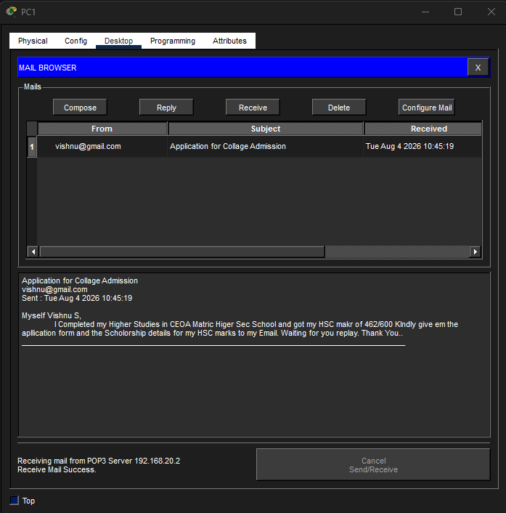
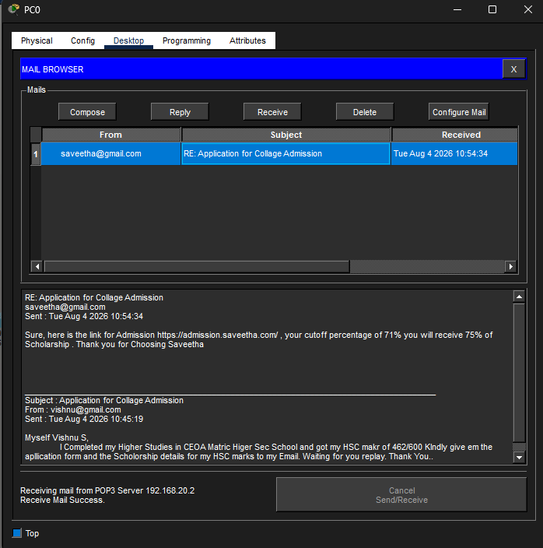
OUTPUT: (Received Email output)

Result
Objective 1: SMTP Protocol
(i) Email communication was successfully established, and email messages were transmitted and received correctly through the mail server using SMTP.

